

**Quick Calligraphy**

**User Guide**

|  |  |  |
| --- | --- | --- |
| **Supervisor.** | **Miss Anum** | |
| **Batch.** | **2306G1** | |
| **Group.** | **A** | |
| **Serial No.** | **Enrollment Number** | **Student Name** |
| 1. | Student1479561 | Nauman Rashid |
| 2. | Student1475155 | M. Arsalan |
| 3. | Student1474867 | Abdul Moiz |
| 4. | Student1476402 | Abid Aslam |

Home Page

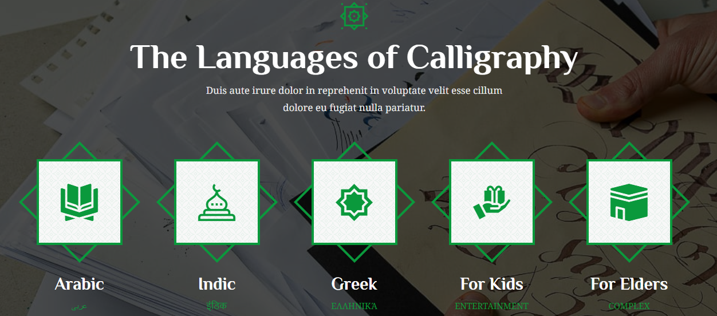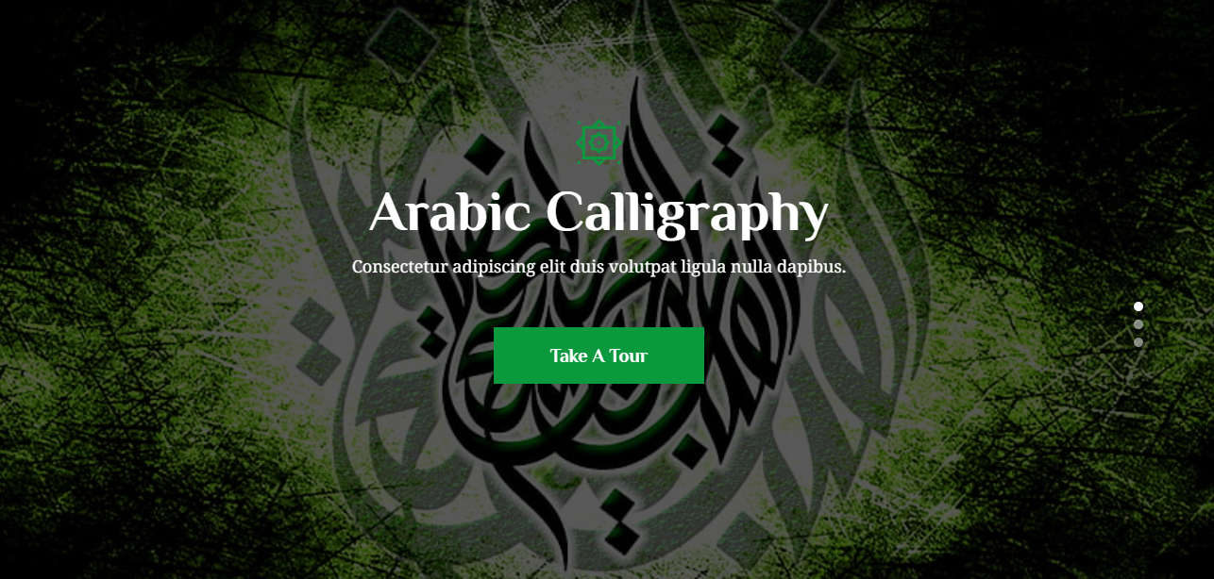What we do (Index.html):

Brief Description:

* In the above pictures we have our home page which contains carousel and give small intro to all 3 languages.
* We have also added some more sections that tells if there is an event on-going or up-coming.
* There is a section which tells the what service we offer.
* There is another section that tells the user what courses we offer.

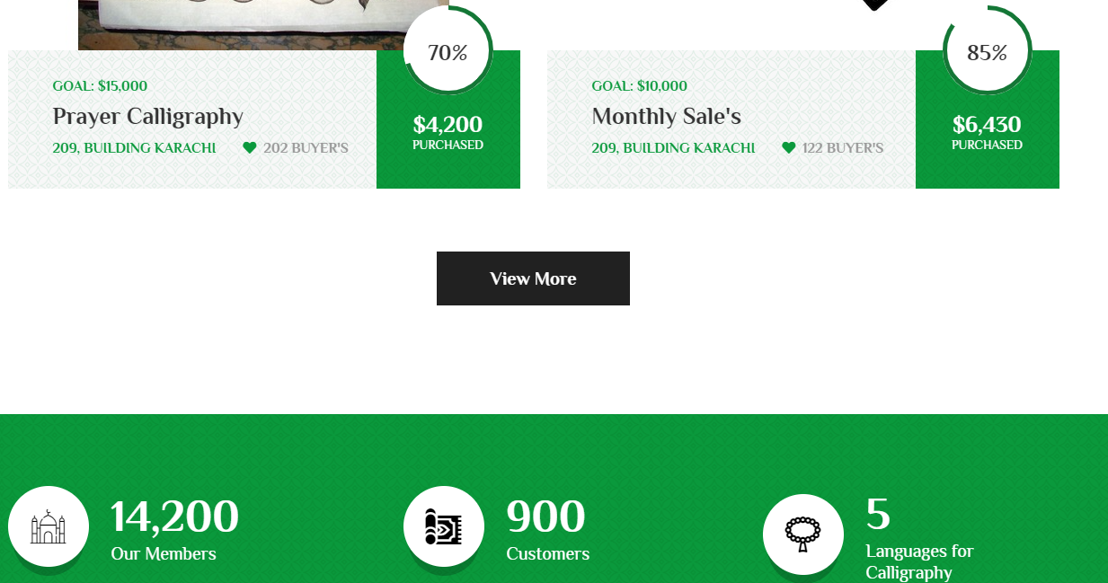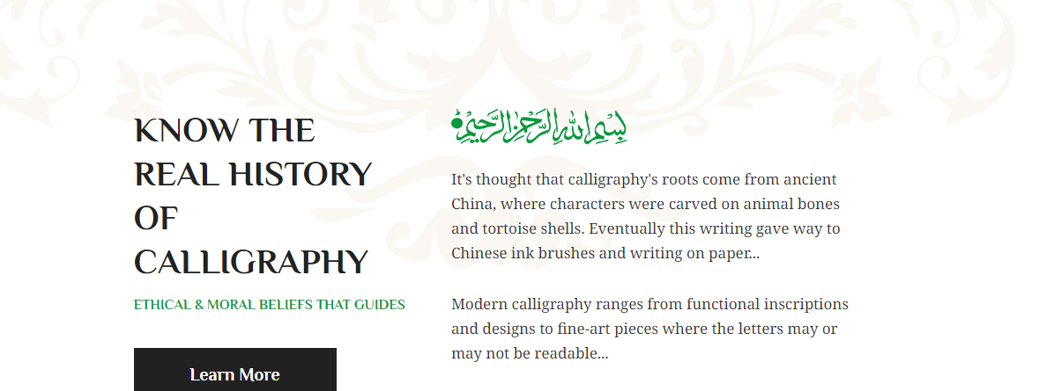How we do it (index2.html):

Brief Description:

* In the above pictures we have our tour home page which contains history of calligraphy and a video link.
* We have also added some more sections gives a small intro to what 3 calligraphy styles look like.
* There is a section which tells & redirects user to calligraphy styles that they want to purchase from us.
* There is another section that tells the user how many we have sold products, how many customers we have.

Navbar:

Brief Description:

* In the above pictures we have our tour nav bar which contain links to all our website so the user can easily navigate from one place to another.
* We have added a button on Contact Us area and styled it to make it look good.

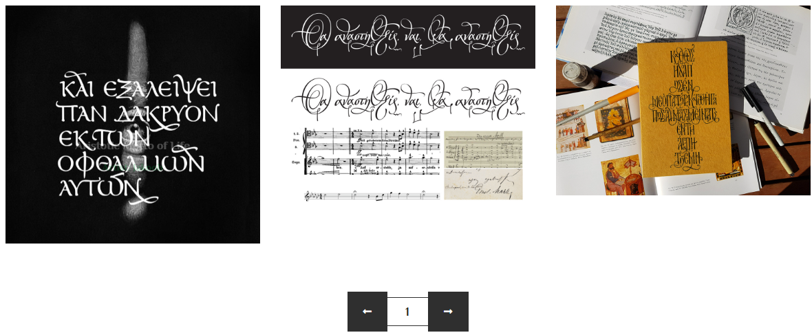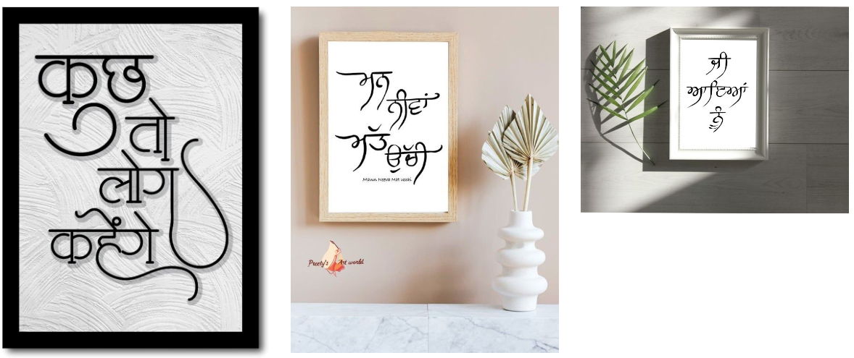Gallery(gallery2.html):

Brief Description:

* In the above pictures we have gallery which contain our portfolio to showcase the user our recently sold products.
* This was made with help of Bootstrap grid columns.

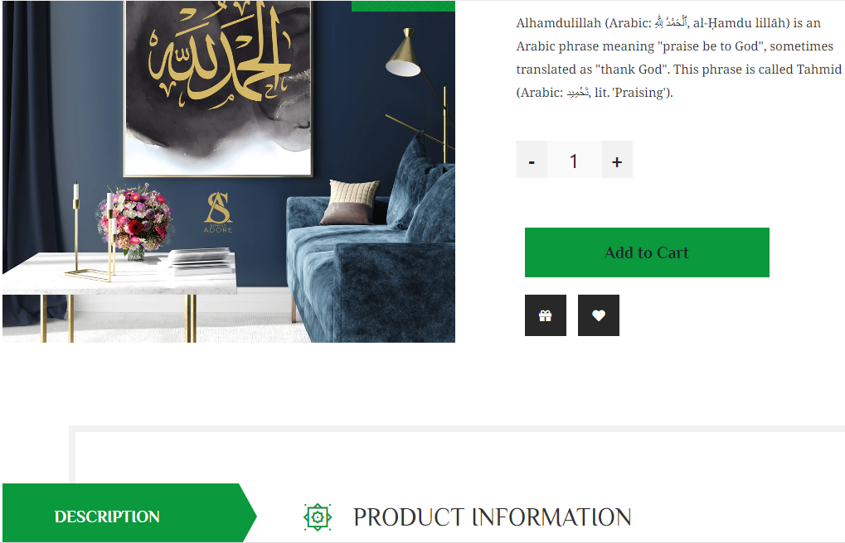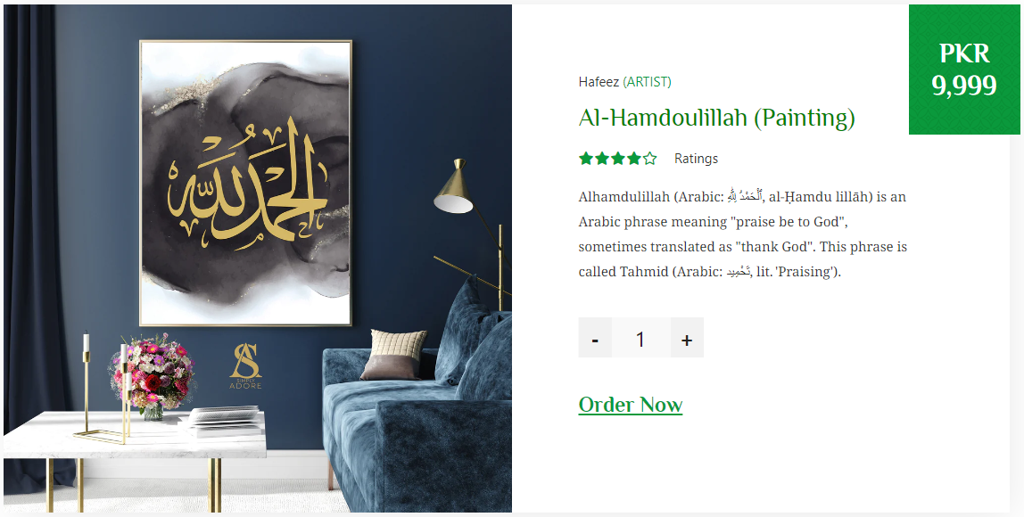Our Products(product.html):

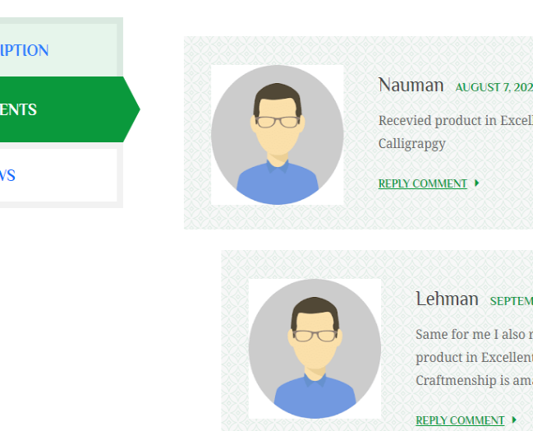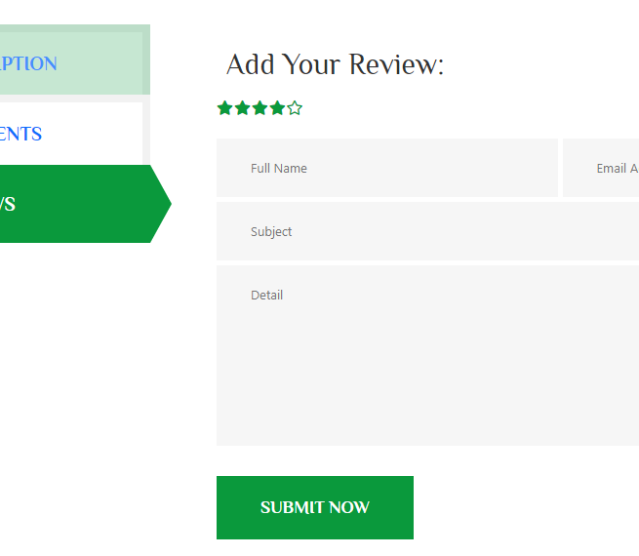

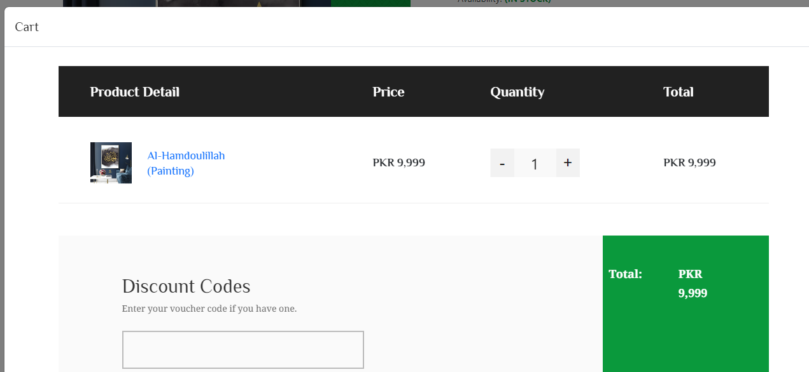

Brief Description:

* In the above pictures we have our product pages which contain our products with description.
* These cards were made with the help of Bootstrap.
* All these cards have link which opens on second page where customer can read the description more easily, provide a review if he/she wants or read previous comments.
* The description also has links to a modal checkout page if someone wants buy a product which was also made with the help of Bootstrap.

Services:

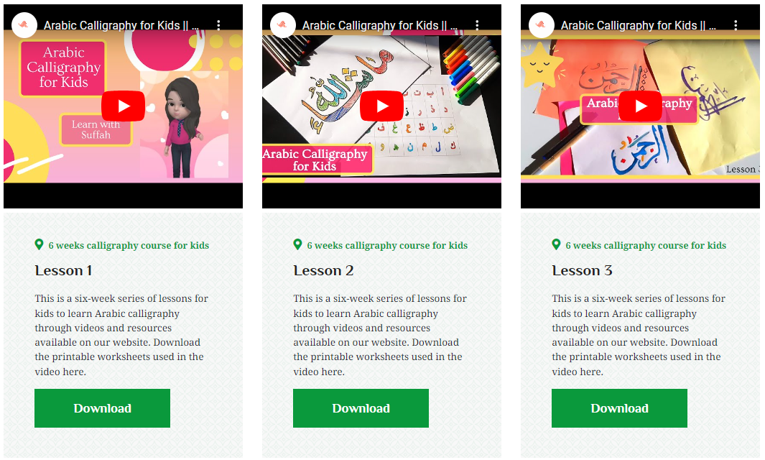For Kids(kids.html):

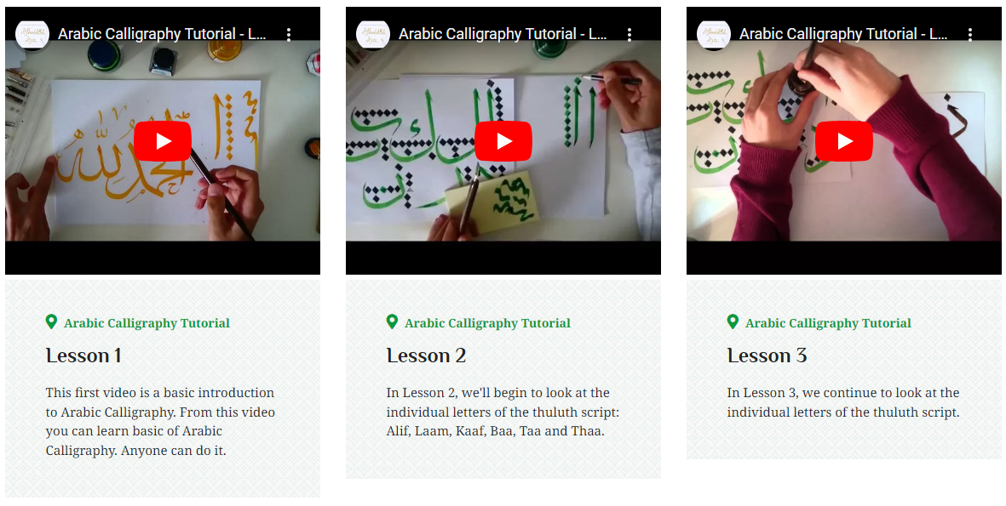For Elders(elder.html):

Brief Description:

* In the above pictures we have our services pages which contain our small videos for kids and elders with description.
* The layout was made with cards from Bootstrap.
* All these cards have link which opens on a YouTube Video link where customer can learn about calligraphy more easily.

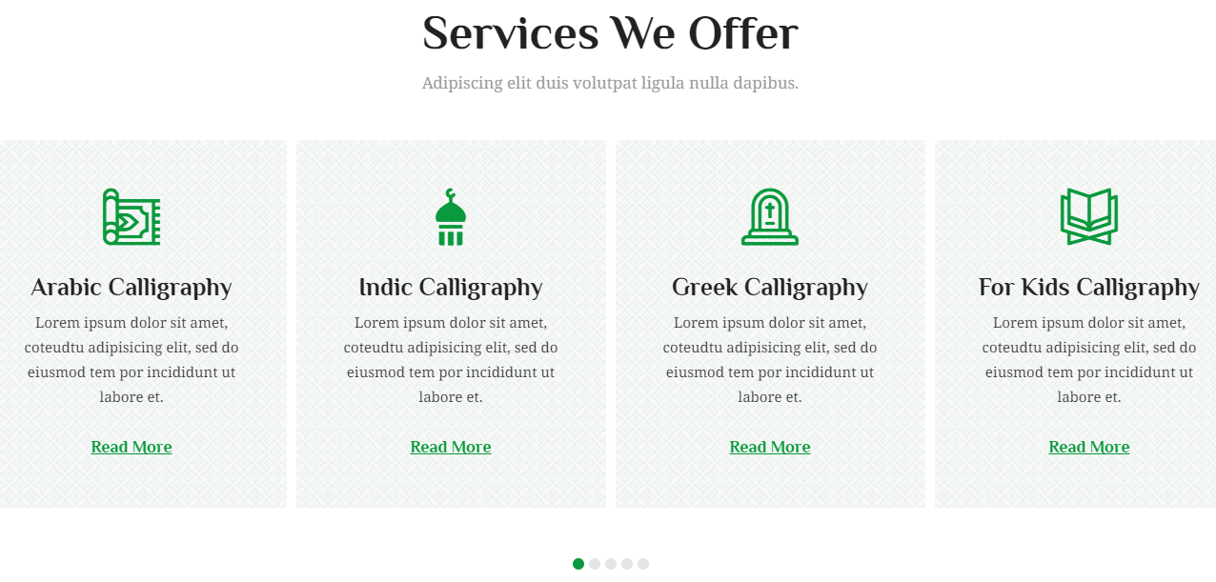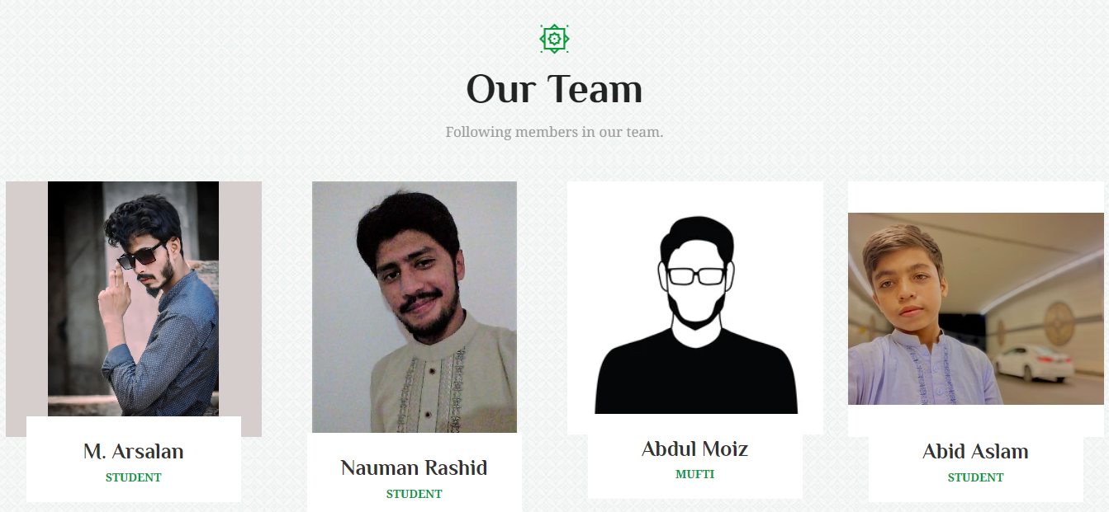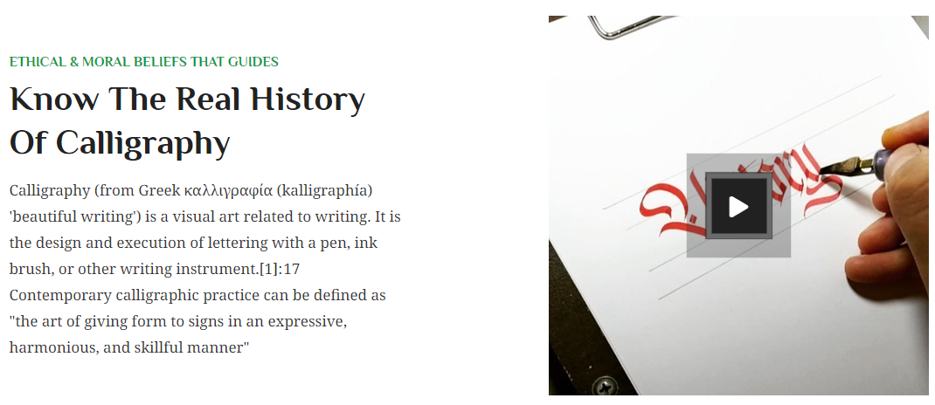About Us:

Brief Description:

* In the above pictures we have our About Us pages small description video about calligraphy and our team.

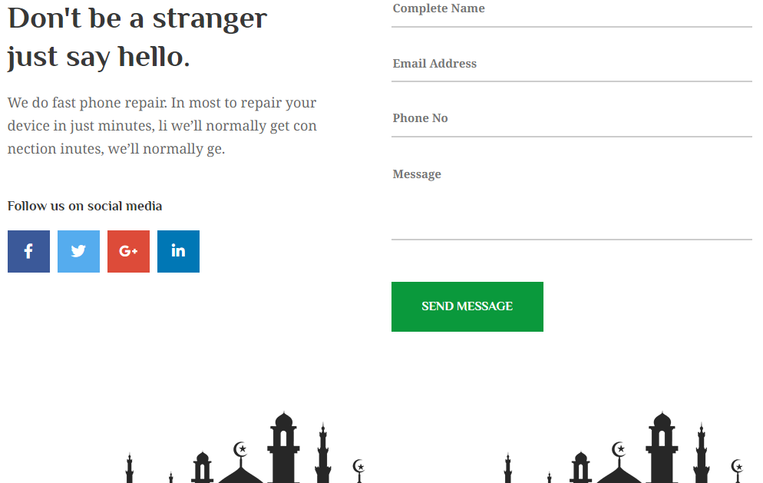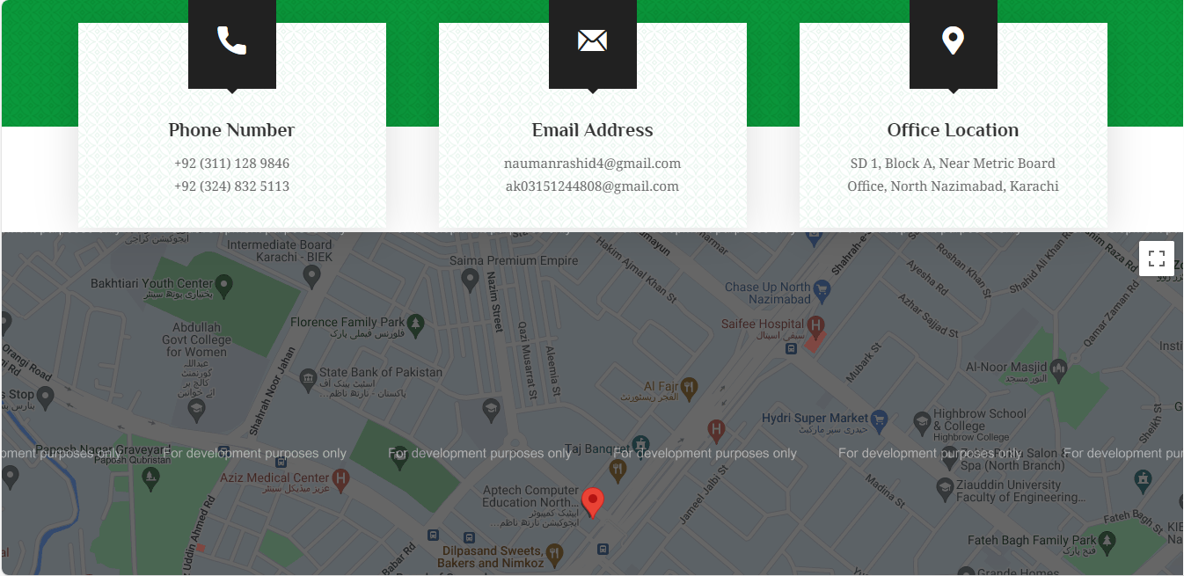Contact Us:

Brief Description:

* In the above pictures we have our contact us page which contain our location, email address and phone numbers.
* The Contact Us page also contains our location using Geo-Location Api.
* This page also contains Contact Us form with form Validation & Links to social media sites.

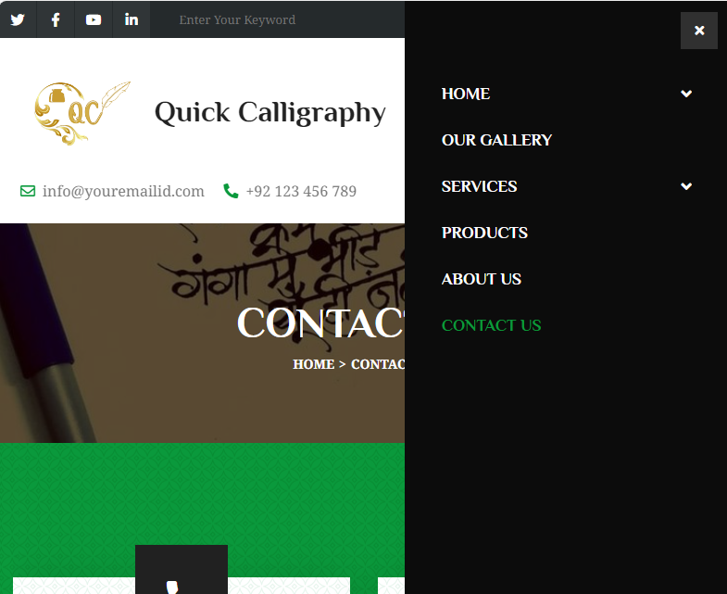Responsive Header:

Brief Description:

* In the above pictures we have our responsive header.
* The header was also made with help of Bootstrap and CSS Styling.

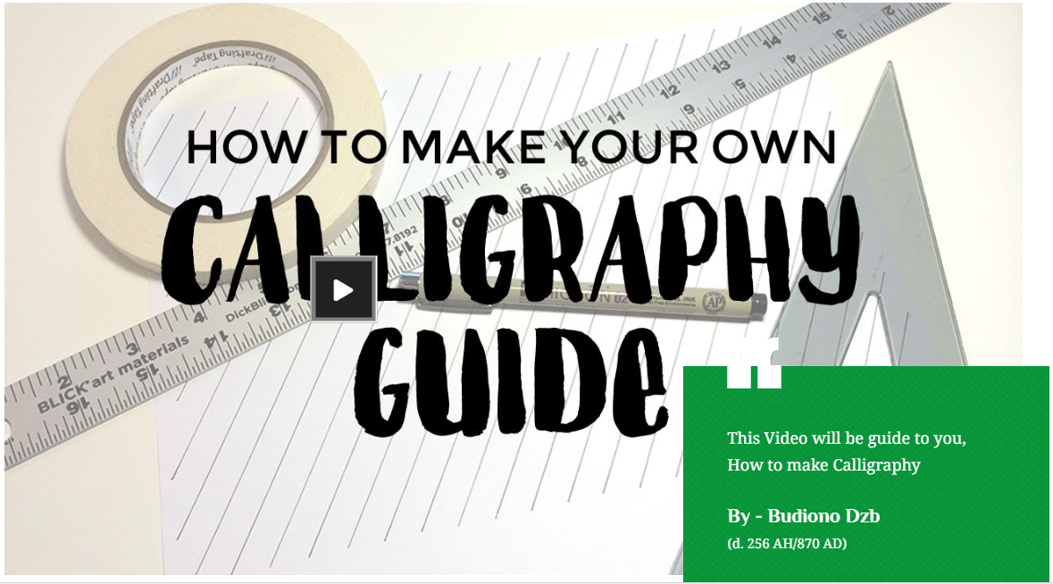Video Links:

Brief Description:

* In the above pictures we have Video link that provide a Brief Guide to Calligraphy.
* The header was also made with help grid column & CSS Styling.

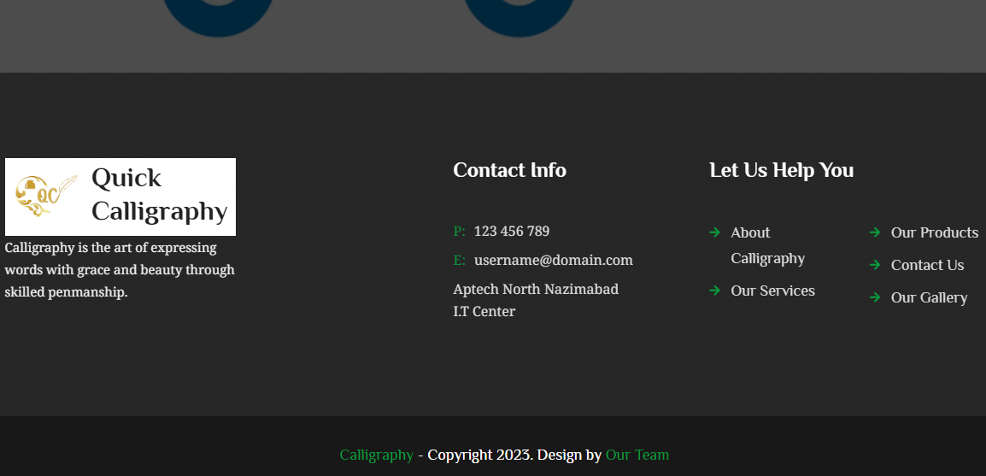Footer:

Brief Description:

* In the above pictures we have our footer on every single which has our logo, copyrights & a few navigations with our contact.

---THE END---